Mixins
Workshop #1
Flutter Developer Bootcamp

Purpose
This workshop demonstrates how to use a mixin called LoggingMixin to provide logging functionality to multiple classes in Dart programming language.

Problem
In the given workshop, there is class named A which uses Logging mixin and it also have instances of class using Logging mixin. You need to create class B and instances of a class B and also create the shared Logging functionality.

How to Solve
1. Checkout the workshop from Git Repo:
git clone -b <user-branch> <repo-URL>
2. Open the root folder inside VS Code
3. Open the root folder in terminal
4. Run the command dart run filename.dart
5. Create class B and instances of class B using mixins.
6. Additionally create Logging functionality.
7. Go To File: <specific-file-with-mixins-method> à <method-name>, implement your mixin logic.

You will Achieve
When you complete this workshop you will learn the following:
- Mixin (LoggingMixin):
- Function: logMessage(String message): This function logs a message to the console. It takes a string message as a parameter and prints it prefixed with "LOG:".
- Class :
- ClassA:
- Method: performAction(): This method belongs to ClassA and represents some action performed by objects of ClassA. Inside this method, it calls the logMessage method inherited from the LoggingMixin to log a message specific to ClassA actions.
- ClassB:
- Method: performTask(): This method belongs to ClassB and represents some task performed by objects of ClassB. Inside this method, it calls the logMessage method inherited from the LoggingMixin to log a message specific to ClassB tasks.
- Main Function:
- Creates instances of ClassA and ClassB.
- Calls the performAction() method on the instanceA object of ClassA, which in turn logs a message related to the action performed by ClassA.
- Calls the performTask() method on the instanceB object of ClassB, which in turn logs a message related to the task performed by ClassB.
- So, the code demonstrates the usage of a mixin to provide shared functionality (logging) to multiple classes (ClassA and ClassB) without code duplication. It logs messages specific to actions/tasks performed by each class instance.

Screenshots

Before implementation (without creating Class B and logging functionality )

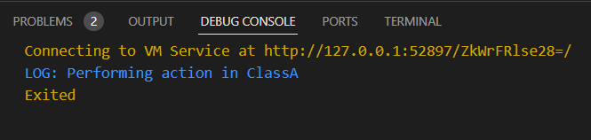

After implementation (With creating Class B and logging functionality)

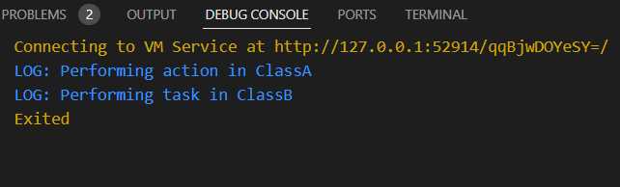

How to submit your workshop
Push your project back to the same git branch using command:
<command name>

Happy Coding!

